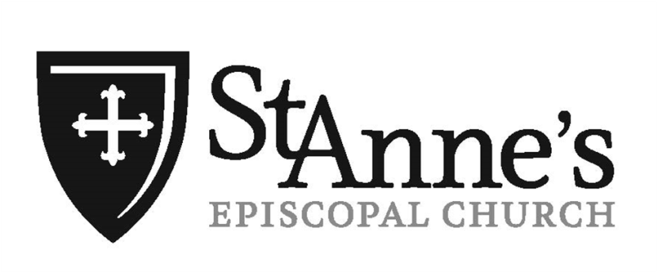

Thirteenth Sunday after Pentecost

September 7, 2025

St Anne’s Episcopal Church
424 W. Market Street—Warsaw, Indiana 46580
574.267.6266
www.stanneswarsaw.org

The Rev. Joseph T. Czolgosz, Interim Priest-in-Charge

The Right Reverend Dr. Douglas E. Sparks
Bishop of Northern Indiana

Good Morning! Sundays we celebrate the Holy Eucharist (Communion) at 8 a.m. and 10:15 a.m. Our liturgy is from the Book of Common Prayer (BCP), found in your pew. Please join us following the service for hospitality in Rose Hall.

All are welcome to the Lord’s Table. It is our custom to receive the bread in our open hands and consume immediately. The chalice will be offered or you may choose an individual cup. We believe Christ is fully present in either element. If you have not been baptized or prefer not to receive Communion, simply cross your arms over your chest and the priest will give you a blessing.

Childcare for infants through preschool is available. Please sign your child in when taking them to the nursery.

If you are visiting today, please sign our guest book in the entrance area.

Restrooms are available. To the right of the entrance and down the hallway.

Serving Today

8 a.m. Eucharistic Ministers: Debbie DeMuth Lectors: Nanette Newland Usher/Greeter: Sharon Lyon

10:15 Crucifer: Bailey Stiver Chalice Bearers: Deb Blatz & Kathy Lee Lector: Joy Craig Greeters: Jerry & Linda Roach Ushers: Cathy Carter & Greg Spiro Hospitality Hosts: Jimmy & Sara Bauman Altar Guild: Debbie DeMuth, Syd Ellis, Sara & Emma Bauman Nursery Volunteers: Doris Banich & Crystal Morsches

The Altar flowers are given to the Greater Glory of God
and in thanksgiving and celebration of our son Christopher on his 30th birthday
by Bob & Cheryl Hastings

Music for today’s worship is used with permission CCLI® Copyright License #1938852

A Reading from the Prophet Jeremiah 18:1-11
The word that came to Jeremiah from the Lord: "Come, go down to the potter's house, and there I will let you hear my words." So I went down to the potter's house, and there he was working at his wheel. The vessel he was making of clay was spoiled in the potter's hand, and he reworked it into another vessel, as seemed good to him.
Then the word of the Lord came to me: Can I not do with you, O house of Israel, just as this potter has done? says the Lord. Just like the clay in the potter's hand, so are you in my hand, O house of Israel. At one moment I may declare concerning a nation or a kingdom, that I will pluck up and break down and destroy it, but if that nation, concerning which I have spoken, turns from its evil, I will change my mind about the disaster that I intended to bring on it. And at another moment I may declare concerning a nation or a kingdom that I will build and plant it, but if it does evil in my sight, not listening to my voice, then I will change my mind about the good that I had intended to do to it. Now, therefore, say to the people of Judah and the inhabitants of Jerusalem: Thus says the Lord: Look, I am a potter shaping evil against you and devising a plan against you. Turn now, all of you from your evil way, and amend your ways and your doings.

Psalm 139:1-5, 12-17
1 Lord, you have searched me out and known me; *
you know my sitting down and my rising up;
you discern my thoughts from afar.
2 You trace my journeys and my resting-places *
and are acquainted with all my ways.
3 Indeed, there is not a word on my lips, *
but you, O Lord, know it altogether.
4 You press upon me behind and before *
and lay your hand upon me.
5 Such knowledge is too wonderful for me; *
it is so high that I cannot attain to it.
12 For you yourself created my inmost parts; *
you knit me together in my mother's womb.
13 I will thank you because I am marvelously made; *
your works are wonderful, and I know it well.
14 My body was not hidden from you, *
while I was being made in secret
and woven in the depths of the earth.
15 Your eyes beheld my limbs, yet unfinished in the womb;
all of them were written in your book; *
they were fashioned day by day,
when as yet there was none of them.
16 How deep I find your thoughts, O God! *
how great is the sum of them!
17 If I were to count them, they would be more in number than the sand; *
to count them all, my life span would need to be like yours.

A Reading from the Epistle of St. Paul to Philemon 1-21
Paul, a prisoner of Christ Jesus, and Timothy our brother, To Philemon our dear friend and co-worker, to Apphia our sister, to Archippus our fellow soldier, and to the church in your house: Grace to you and peace from God our Father and the Lord Jesus Christ.
When I remember you in my prayers, I always thank my God because I hear of your love for all the saints and your faith toward the Lord Jesus. I pray that the sharing of your faith may become effective when you perceive all the good that we may do for Christ. I have indeed received much joy and encouragement from your love, because the hearts of the saints have been refreshed through you, my brother.
For this reason, though I am bold enough in Christ to command you to do your duty, yet I would rather appeal to you on the basis of love-- and I, Paul, do this as an old man, and now also as a prisoner of Christ Jesus. I am appealing to you for my child, Onesimus, whose father I have become during my imprisonment. Formerly he was useless to you, but now he is indeed useful both to you and to me. I am sending him, that is, my own heart, back to you. I wanted to keep him with me, so that he might be of service to me in your place during my imprisonment for the gospel; but I preferred to do nothing without your consent, in order that your good deed might be voluntary and not something forced. Perhaps this is the reason he was separated from you for a while, so that you might have him back forever, no longer as a slave but more than a slave, a beloved brother-- especially to me but how much more to you, both in the flesh and in the Lord.
So if you consider me your partner, welcome him as you would welcome me. If he has wronged you in any way, or owes you anything, charge that to my account. I, Paul, am writing this with my own hand: I will repay it. I say nothing about your owing me even your own self. Yes, brother, let me have this benefit from you in the Lord! Refresh my heart in Christ. Confident of your obedience, I am writing to you, knowing that you will do even more than I say.

The Holy Gospel of Our Lord Jesus Christ According to Luke 14:25-33
Now large crowds were traveling with Jesus; and he turned and said to them, "Whoever comes to me and does not hate father and mother, wife and children, brothers and sisters, yes, and even life itself, cannot be my disciple. Whoever does not carry the cross and follow me cannot be my disciple. For which of you, intending to build a tower, does not first sit down and estimate the cost, to see whether he has enough to complete it? Otherwise, when he has laid a foundation and is not able to finish, all who see it will begin to ridicule him, saying, `This fellow began to build and was not able to finish.' Or what king, going out to wage war against another king, will not sit down first and consider whether he is able with ten thousand to oppose the one who comes against him with twenty thousand? If he cannot, then, while the other is still far away, he sends a delegation and asks for the terms of peace. So therefore, none of you can become my disciple if you do not give up all your possessions."

8 a.m. – Rite One
Opening Acclamation Prayer Book p. 323

The Collect for Purity

Gloria in Excelsis 324
The Collect of the Day

First Reading – Jeremiah 18:1-11

Psalm 139:1-5, 12-17 found on page 794 in the BCP or page 3 in the bulletin
Second Reading – Philemon 1-21

The Holy Gospel All stand. – Luke 14:25-33

Sermon Bishop Doug Sparks

Nicene Creed BCP p. 326

Prayers of the People Stand or kneel as you prefer. 328

The Peace Announcements & Blessings

The Great Thanksgiving—Sanctus 340

Eucharistic Prayer II Stand or kneel as you are able. 340

Lord’s Prayer & Breaking of the Bread 336-337

Administration of Communion

Post-Communion Prayer Said by all in unison, standing or kneeling as you prefer. 339

Blessing & Dismissal 340

10:15 a.m.—Rite Two

Prelude - Organ

At the entrance of the ministers, all stand and sing the
Entrance Hymn 544 Jesus shall reign where ‘er the sun…

Opening Acclamation
Celebrant Blessed be God, Father, Son and Holy Spirit
People And blessed be his kingdom, now and forever. Amen.

The Collect for Purity

Gloria in excelsis Glory to God in the highest…
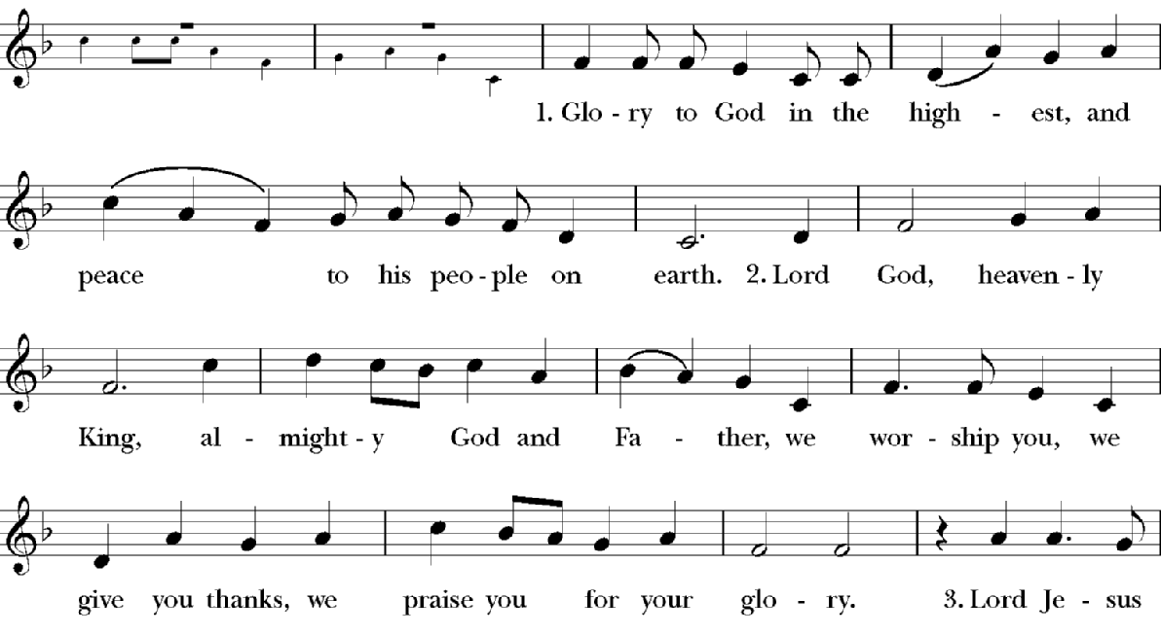

Celebrant The Lord be with you.
People And also with you.
Celebrant Let us pray.

The Collect of the Day
Grant us, O Lord, to trust in you with all our hearts; for, as you always resist the proud who confide in their own strength, so you never forsake those who make their boast of your mercy; through Jesus Christ our Lord, who lives and reigns with you and the Holy Spirit, one God, now and for ever. Amen.

Please be seated.

A Reading from the Prophet Jeremiah 18:1-11
At the conclusion, the lector says
The Word of the Lord.
People Thanks be to God.

Please join in reading Psalm 139:1-5, 12-17 found on page 794 in the Book of Common Prayer
1 Lord, you have searched me out and known me; *
you know my sitting down and my rising up;
you discern my thoughts from afar.
2 You trace my journeys and my resting-places *
and are acquainted with all my ways.
3 Indeed, there is not a word on my lips, *
but you, O Lord, know it altogether.
4 You press upon me behind and before *
and lay your hand upon me.
5 Such knowledge is too wonderful for me; *
it is so high that I cannot attain to it.
12 For you yourself created my inmost parts; *
you knit me together in my mother's womb.
13 I will thank you because I am marvelously made; *
your works are wonderful, and I know it well.
14 My body was not hidden from you, *
while I was being made in secret
and woven in the depths of the earth.
15 Your eyes beheld my limbs, yet unfinished in the womb;
all of them were written in your book; *
they were fashioned day by day,
when as yet there was none of them.
16 How deep I find your thoughts, O God! *
how great is the sum of them!
17 If I were to count them, they would be more in number than the sand; *
to count them all, my life span would need to be like yours.

A Reading from the Epistle St. Paul to Philemon 1-21
At the conclusion, the lector says The Word of the Lord. People Thanks be to God.

Gospel Acclamation
All stand. An Alleluia refrain is introduced by the choir or cantor and repeated by twice the congregation.

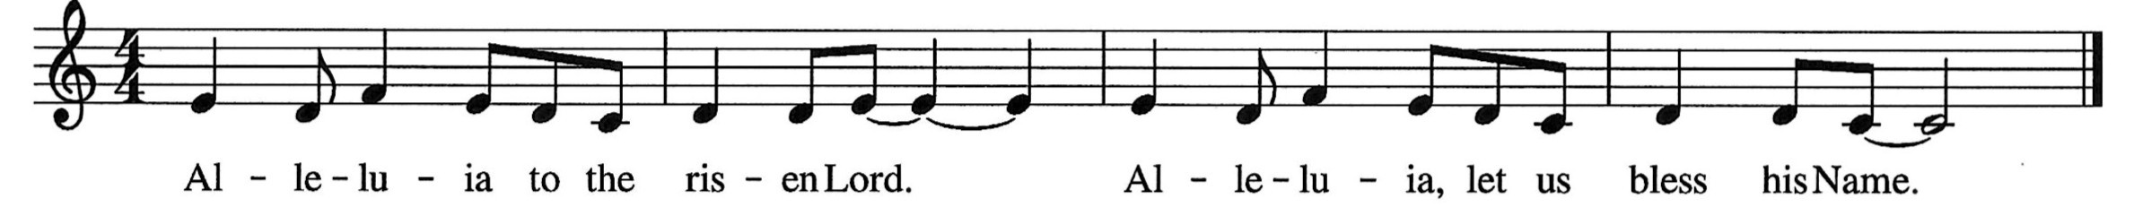

The Holy Gospel of Our Lord Jesus Christ According Luke 14:25-33
When the Priest announces the Gospel, all respond
Glory to you, Lord Christ.

At the conclusion the reader says
The Gospel of the Lord
People Praise to you, Lord Christ.

Homily – Bishop Doug Sparks

All stand and recite the

Nicene Creed
We believe in one God, the Father, the Almighty,
maker of heaven and earth, of all that is, seen and unseen.
We believe in one Lord, Jesus Christ, the only Son of God,
eternally begotten of the Father, God from God, Light from Light,
true God from true God, begotten, not made, of one Being with the Father.
Through him all things were made.
For us and for our salvation he came down from heaven:
by the power of the Holy Spirit
he became incarnate from the Virgin Mary, and was made man.
For our sake he was crucified under Pontius Pilate;
he suffered death and was buried.
On the third day he rose again in accordance with the Scriptures;
he ascended into heaven and is seated at the right hand of the Father.
He will come again in glory to judge the living and the dead,
and his kingdom will have no end.
We believe in the Holy Spirit, the Lord, the giver of life,
who proceeds from the Father and the Son.
With the Father and the Son he is worshiped and glorified.
He has spoken through the Prophets.
We believe in one holy catholic and apostolic Church.
We acknowledge one baptism for the forgiveness of sins.
We look for the resurrection of the dead,
and the life of the world to come. Amen.

Prayers of the People - Form VI
The Leader and People pray responsively
In peace, we pray to you, Lord God.
Silence
For all people in their daily life and work;
For our families, friends, and neighbors, and for those who are alone.
For this community, the nation, and the world;
For all who work for justice, freedom, and peace.

For the just and proper use of your creation;
For the victims of hunger, fear, injustice, and oppression.

For all who are in danger, sorrow, or any kind of trouble;
For those who minister to the sick, the friendless, and the needy.

For the peace and unity of the Church of God;
For all who proclaim the Gospel, and all who seek the Truth.
For Sean our Presiding Bishop, and Douglas our Bishop; and for all bishops and other ministers;
For all who serve God in his Church.

For the Search Committee and Vestry of St. Anne’s, guide the minds and hearts of those who will choose a faithful priest to care for and equip us for your ministries.
For your will to be discerned.

For the special needs and concerns of this congregation. We pray especially for: Judy, Mike, Lutie, Polly, Sharon, Olivia, Nanette, Cherine, Elizabeth, Leanne, Scott, Brittany, Malcolm, Kimm, Patty, Ryan, Amy, Paddy, Sean, Larkin, Jane, Bill, Kathy, Jan, Sara, Pat, Tyler, Gabe, Bonnie, Mary Louise, Clay, Abagail, Rob, Michelle, Taylor, John, Gary, Edith, Dave, Travis, Cody, Brandy, Becki, Pam, Nanette, Atlanta, Mildred, Riley, Judith, Scott, Kim, Lorraine, Susan, and the Women of Cell Blocks B & D. I ask your prayers for the following families: the Teeple, Shufelt, Basden, Smith, Stoffel, Parker, Eastlund, Milliman, Walmer and Jagger. We pray for those in the Armed Forces: Aidan, Graham, T.J., Ethan & Colton. We pray for St. Timothy’s Episcopal Church in Griffith which is part of the Calumet Episcopal Ministry Partnership in the Diocesan Cycle of Prayer. We pray for The Church of South India in the Anglican Cycle of Prayer. We pray for those affected by natural and manmade disasters. We pray for all your precious children, please hold and protect them.

The People may add their own petitions
Hear us, Lord;
For your mercy is great.

We thank you, Lord, for all the blessings of this life.
Silence
The People may add their own thanksgivings
We will exalt you, O God our King;
And praise your Name for ever and ever.
We pray for all who have died, remembering: Rod, Eileen, Richard, Jeff, Haley, Hal and Adam that they may have a place in your eternal kingdom.
Silence
The People may add their own petitions
Lord, let your loving-kindness be upon them;
Who put their trust in you.

We pray to you also for the forgiveness of our sins.

Silence may be kept. You may stand or kneel as you prefer.
Leader and People
Have mercy upon us, most merciful Father; in your compassion forgive us our sins,
known and unknown, things done and left undone; and so uphold us by your Spirit
that we may live and serve you in newness of life, to the honor and glory of your Name;
through Jesus Christ our Lord. Amen.

The Peace

The Celebrant says
The peace of the Lord be always with you.
People And also with you.
The ministers and people greet one another in the name of the Lord.

Announcements & Blessings

Birthday Blessing:

Watch over your children, O Lord, as their days increase; bless and guide them wherever they may be. Strengthen them when they stand; comfort them when discouraged or sorrowful; raise them up if they fall; and in their hearts may thy peace which passes understanding abide all the days of their lives; through Jesus Christ our Lord. Amen.

The Holy Communion

Offertory Hymn 581 Where charity and love prevail…

Celebrant All things come of thee O Lord.
People And of thine own have we given thee.

The Great Thanksgiving

The Celebrant announces the corporate Eucharistic Intention, followed by

Eucharistic Prayer A (Book of Common Prayer, p. 361)
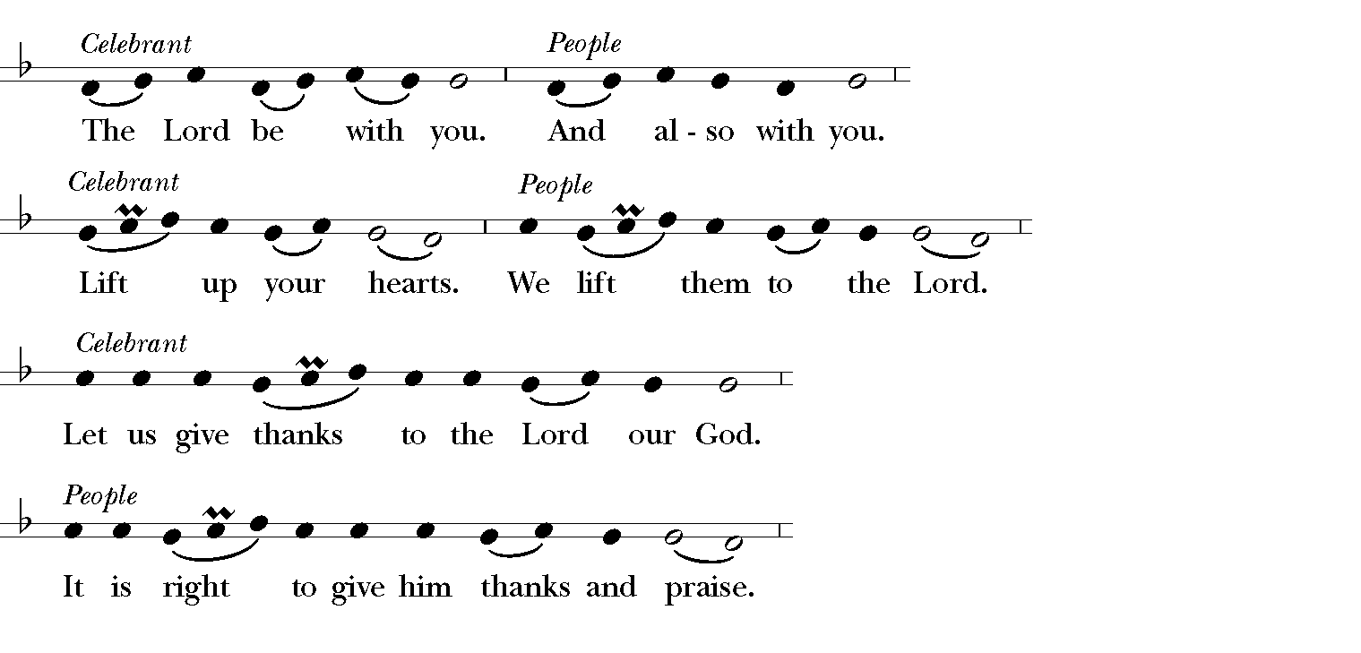
Then, facing the Holy Table, the Celebrant proceeds
It is right, and a good and joyful thing, always and every-where to give thanks to you, Father Almighty, Creator of heaven and earth.
Proper Preface
Therefore we praise you, joining our voices with Angels and Archangels and with all the company of heaven, who for ever sing this hymn to proclaim the glory of your Name:

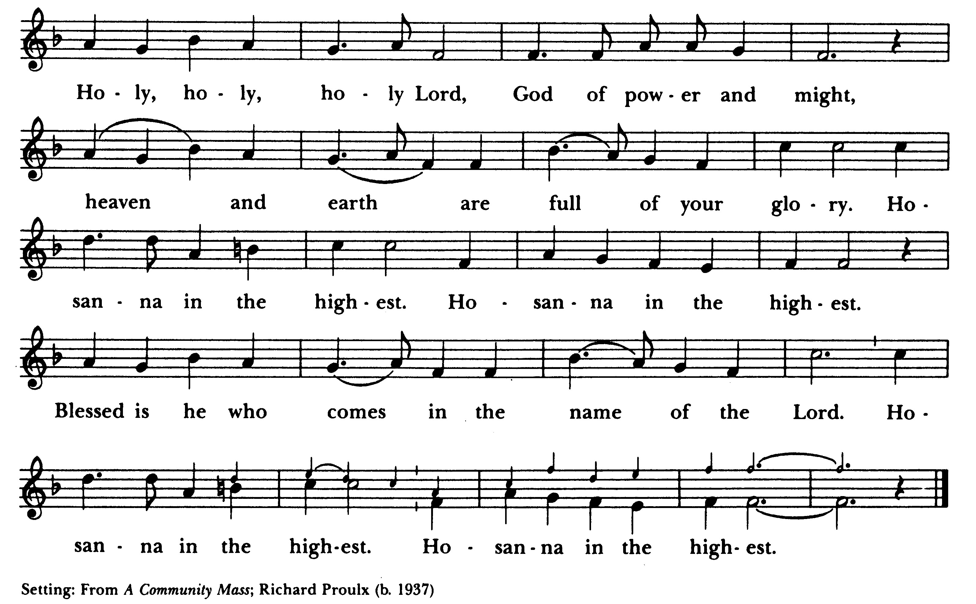
Sanctus

The people stand or kneel.
Then the Celebrant continues
Holy and gracious Father: In your infinite love you made us for yourself, and, when we had fallen into sin and become subject to evil and death, you, in your mercy, sent Jesus
Christ, your only and eternal Son, to share our human nature, to live and die as one of us, to reconcile us to you, the God and Father of all.
He stretched out his arms upon the cross, and offered himself, in obedience to your will, a perfect sacrifice for the whole world.
At the following words concerning the bread, the Celebrant is to hold it, or to lay a hand upon it; and at the words concerning the cup, to hold or place a hand upon the cup and any other vessel containing wine to be consecrated.
On the night he was handed over to suffering and death, our Lord Jesus Christ took bread; and when he had given thanks to you, he broke it, and gave it to his disciples, and said, "Take, eat: This is my Body, which is given for you. Do this for the
remembrance of me."
After supper he took the cup of wine; and when he had given thanks, he gave it to them, and said, "Drink this, all of you: This is my Blood of the new Covenant, which is shed for you and for many for the forgiveness of sins. Whenever you drink it, do this for the remembrance of me."
Therefore we proclaim the mystery of faith:
Celebrant and People
Christ has died. Christ is risen. Christ will come again.
The Celebrant continues
We celebrate the memorial of our redemption, O Father, in this sacrifice of praise and thanksgiving. Recalling his death, resurrection, and ascension, we offer you these gifts.
Sanctify them by your Holy Spirit to be for your people the Body and Blood of your Son, the holy food and drink of new and unending life in him. Sanctify us also that we may faithfully receive this holy Sacrament, and serve you in unity, constancy, and peace; and at the last day bring us with all your saints into the joy of your eternal kingdom.
All this we ask through your Son Jesus Christ: By him, and with him, and in him, in the unity of the Holy Spirit all honor and glory is yours, Almighty Father, now and for ever. AMEN.
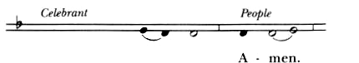
By him, and with him and in him, in the unity of the Holy Spirit all honor and glory is yours, Almighty Father, now and for ever.

As our Savior Christ has taught us, we now pray,

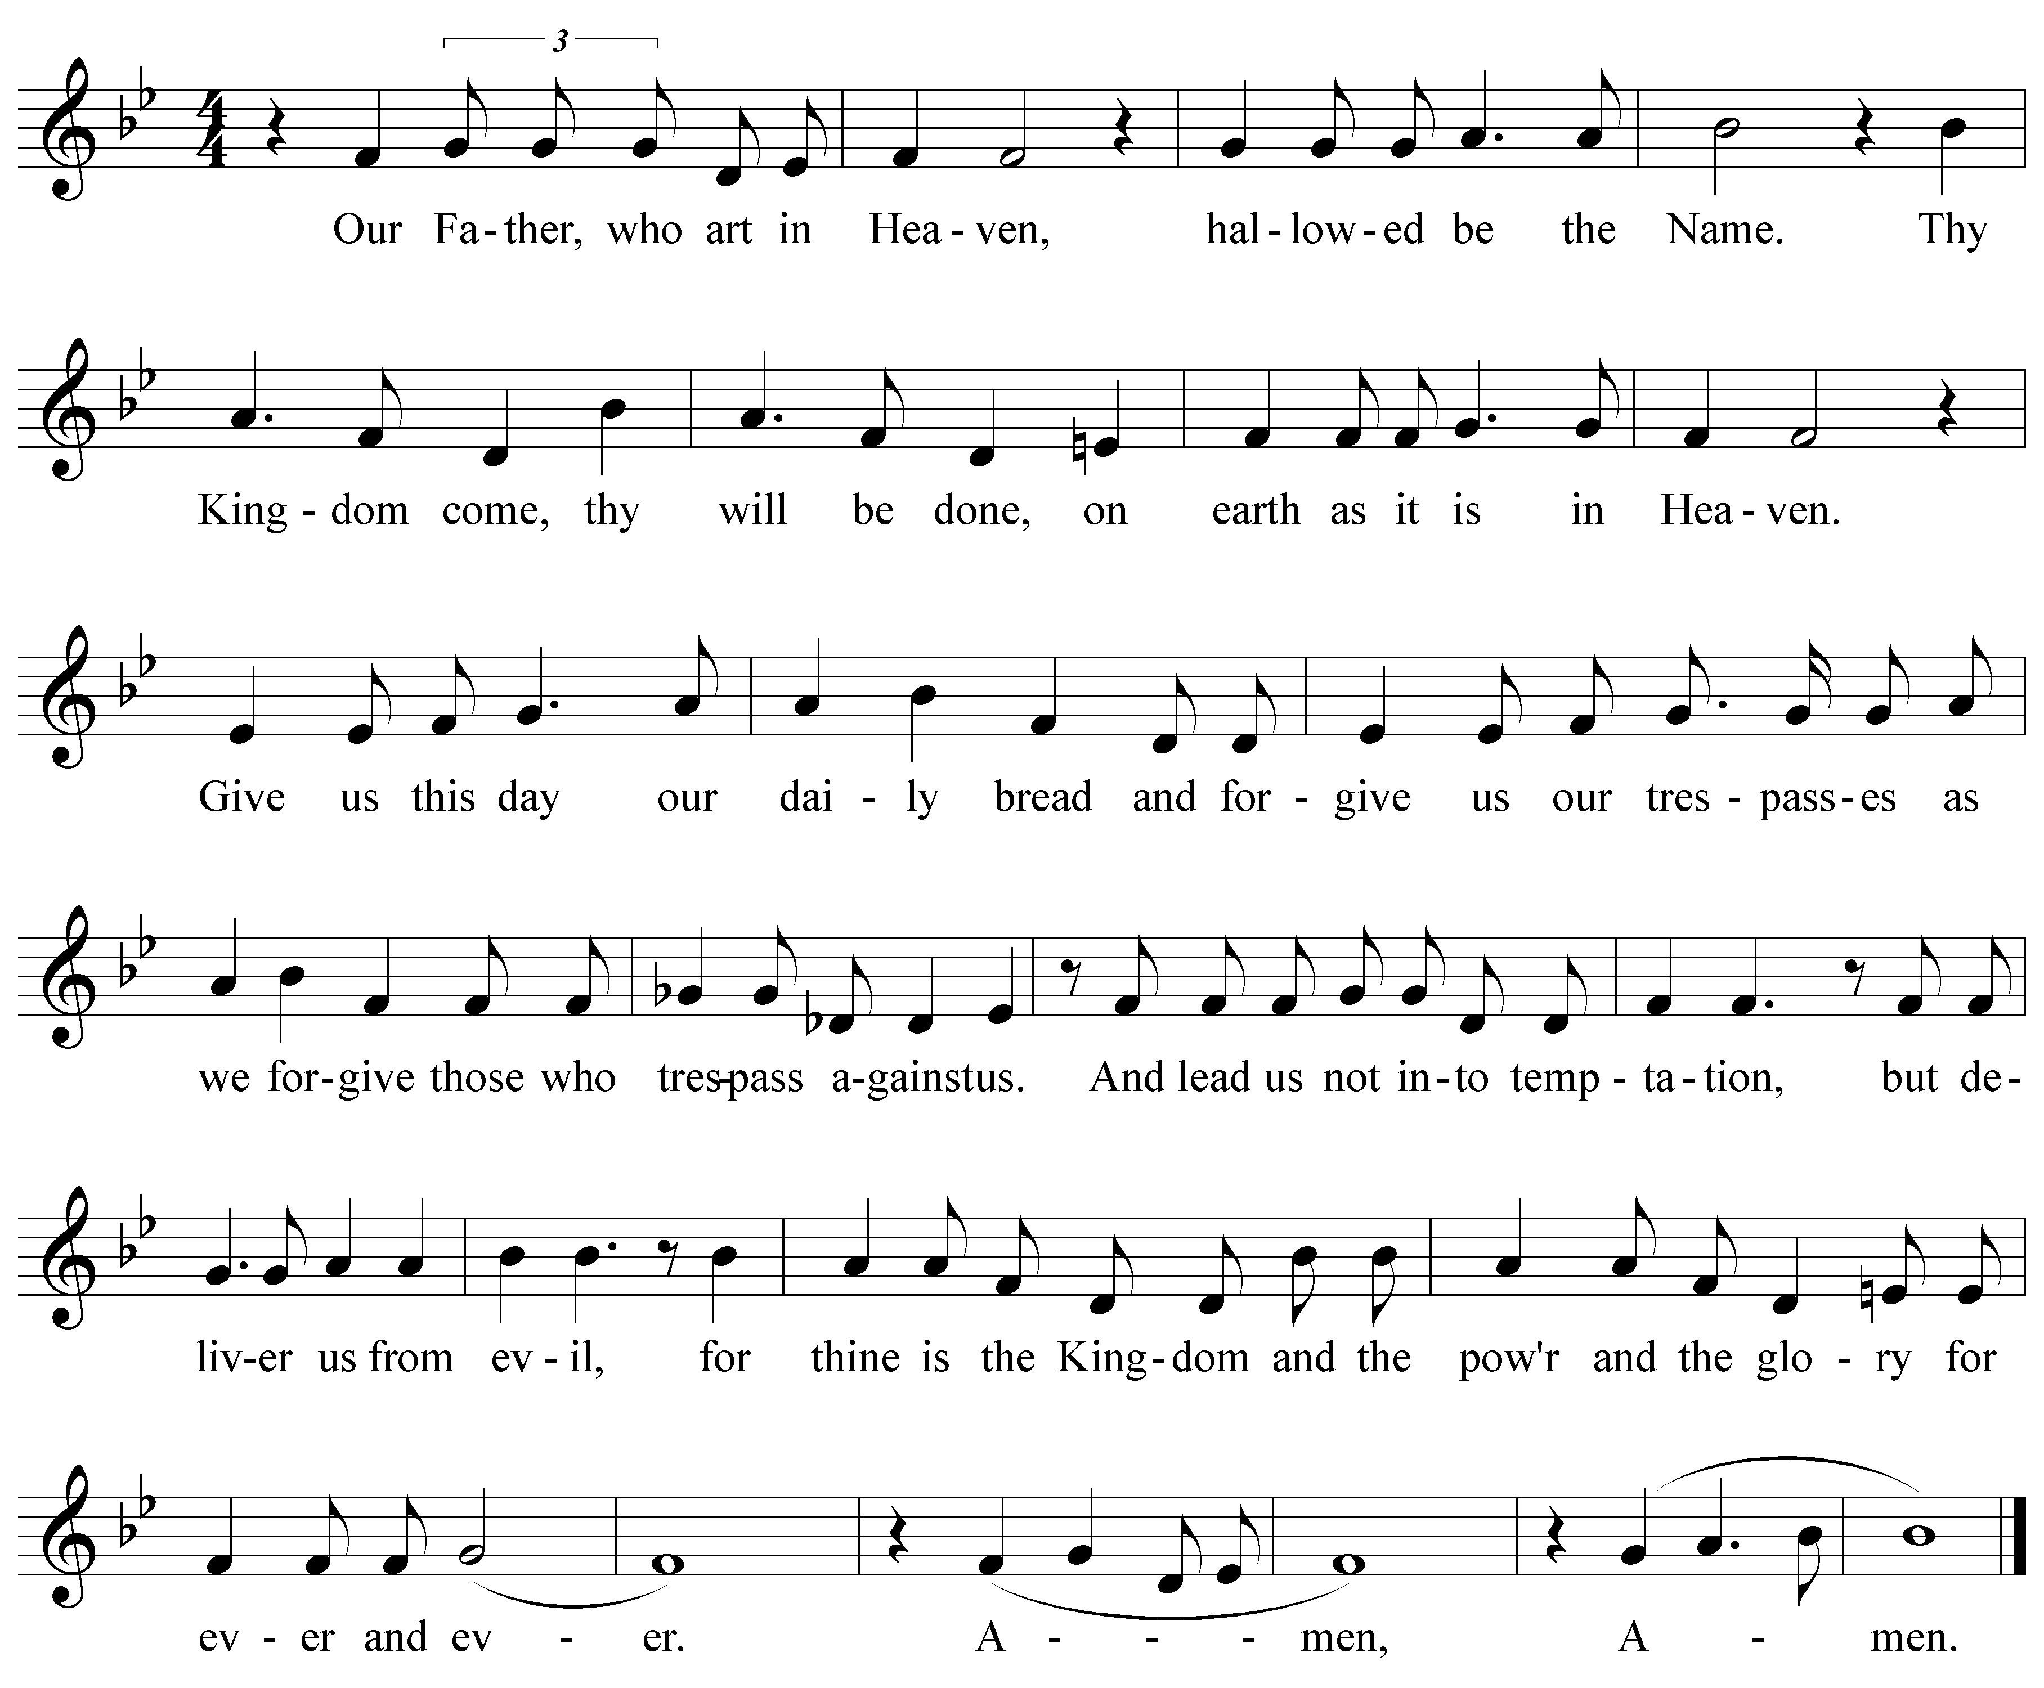
The Lord’s Prayer Written by Joseph Lowe

The Breaking of the Bread
The Celebrant breaks the consecrated Bread. A period of silence is kept.

The Fraction Anthem
Sung by a cantor or the choir.
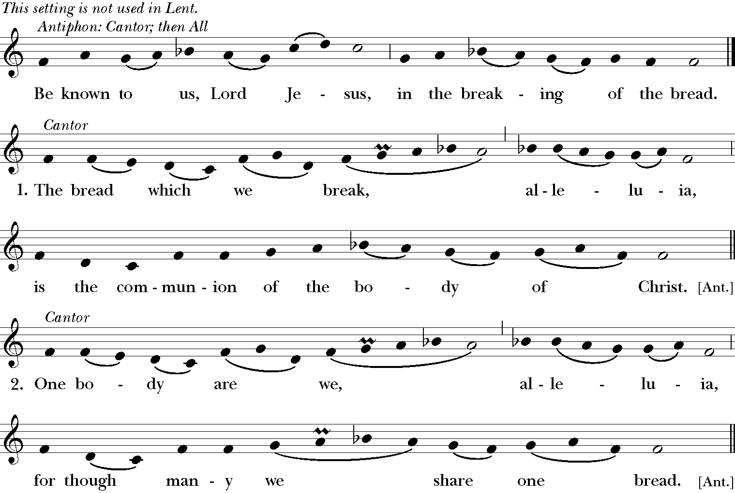

Facing the people, the Celebrant says
The Gifts of God for the People of God.

The minister receives the Sacrament in both kinds, and then immediately deliver it to the people.

Communion Anthem “Pie Jesu” – Duet: Joy Craig & Bob Jarboe
Translation: Merciful Jesus, Father, who takes away the sins of the world,
grant them rest.
Lamb of God, Father, who takes away the sins of the world, grant them rest
everlasting.

The Post-Communion Prayer
Celebrant says Let us pray.

Celebrant and People
Eternal God, heavenly Father, you have graciously accepted us as living members of your Son our Savior Jesus Christ, and you have fed us with spiritual food in the Sacrament of his Body and Blood. Send us now into the world in peace, and grant us strength and courage to love and serve you with gladness and singleness of heart; through Christ our Lord. Amen.

The Blessing Life is short, and we do not have much time to gladden the hearts of those who make the journey with us. So be swift to love, and make haste to be kind, forgiving and compassionate.

Dismissal Hymn 688 A mighty fortress is our God…

Dismissal
Celebrant Let us go forth into the world, rejoicing in the power of the Spirit.
People Thanks be to God.

Postlude

THIS WEEK AT ST. ANNE’S
WELCOME If you are a guest and visiting us for the first time, please join us for Hospitality Hour following the service. We are so grateful to have you here. We would like to welcome the Postulants and Candidates of the Diocese of Northern Indiana along with Bishop Doug Sparks and Canon Terri Bays. They have been in Warsaw for the weekend using St. Anne’s for their retreat space. It’s great to have you here.

SEARCH COMMITTEE UPDATE St. Anne’s Parish Profile and the OTM (Office for Transition Ministries) Profile are in the hands of Canon Terri Bays and we are hopeful that soon we will be receiving inquiries from rector candidates.

AUGUST OUTREACH OF THE MONTH – WCHS (Warsaw Community High School) PANTRY During the school year, students can stop in for needs that come up throughout the day. Please donate nonperishable food items: cereal, bottled juice (no glass), canned vegetables/fruits, granola bars, snack foods, instant macaroni and cheese, instant flavored oatmeal, etc. Other items: deodorant, tooth brushes, tooth paste, feminine products. Nonfood items are most needed at this time. Monetary donations are welcome, please make checks payable to St. Anne’s and write WCHS Pantry on the memo line.

SAMS (St. Anne’s Men’s Society) & ECW (Episcopal Church Women) Will meet at the home of Cathy Carter on September 8 at 6:30 p.m. Please bring all of your aluminum cans for recycle, this is a new fund raiser for SAMS and ECW.

CARE COMMITTEE – SOUND DURING WORSHIP Do you have trouble hearing, I said DO YOU HAVE TROUBLE HEARING our services in the sanctuary? If so, we’d like to hear from you! We are researching improvements to our sound system to make it easier for everyone to hear everything. Some options work through an app on your phone and some are able to send sound directly to personal hearing aids. In order to choose the option that works best for most people, we are collecting information on cell phone usage and hearing aid models. Printed surveys are available on the gift counter in Rose Hall or we can email a survey to you by asking Carol Bianchini, office@stanneswarsaw.org or Cheryl Hastings, bchastings6@comcast.net. Please return surveys either to the box on the gift counter or by submitting them electronically. https://forms.gle/BpoPja8yBmc5f5bJ8

ST. ANNE’S SPIRITUAL GIFTS QUESTIONNAIRE St. Anne’s has access to a Spiritual Gifts Questionnaire that will be used to help our members identify their God-given talents and interests to better engage God’s call/vocation to each baptized person. Parishioners can go to our website: http://www.stanneswarsaw.org, search the opening banner across the top of the webpage and click on the hyperlink “Spiritual Gifts and Ministry Guide.” On this webpage, after an initial definition of “Spiritual Gifts,” you will find an option to access the “Digital Spiritual Gifts Questionnaire.” If you prefer, the Questionnaire in hard copy form, these are provided for you on the gift counter in Rose Hall. In preparation for welcoming our new Rector when chosen, all adult members (16 years old and older) are asked to complete the Spiritual Gifts Questionnaire and identify where your God-given talents can best be utilized in the ministries of St. Anne’s. If you have questions or concerns about your spiritual gifts, the Questionnaire, how to score your results, please contact Fr. Joe (847-363-7572), Julie Kuhn (574-453-6327), or Brenda Rigdon (574-268-8259). Thank You!

MORNING PRAYER is offered on Monday and Tuesday mornings at 9 a.m.

EVENING PRAYER is offered on Monday evening at 5:30 p.m.

MID WEEK HOLY EUCHARIST is offered on Tuesday at 5:30 p.m.

VISITS WITH FR. JOE If you would like to schedule a meeting, you can call the office or may also call Fr. Joe directly at 847-363-7572. Blessings and thank you!

ON-GOING EVENTS - REFLECTIONS BIBLE STUDY Meets on Tuesday morning at 10 a.m. in the parlor to study the readings for the upcoming Sunday.

UPCOMING EVENTS
ST. ANNE’S EPISCOPAL CHURCH CELEBRATES 75 YEARS Our Diamond Jubilee!
St Anne’s is celebrating our 75th Anniversary on September 27 and you are invited!

We will meet at the church at 4:30, and begin a pilgrimage walk to the places in Warsaw where we worshipped before purchasing this building. Golf carts will be available to carry those who wish to join in but do not feel up to walking several blocks. The Pilgrimage will be followed by a catered dinner and program in Rose Hall. Invitations are going out in the mail this week, and you must RSVP no later than September 13.
Bp. Doug will be here, along with other friends and clergy from our years together. We do hope you can join us for this important occasion in the life of our Parish.
If you would like to make contributions toward this wonderful celebration, please mail or place your checks in the offering plate with 75th Anniversary on the memo line. Donors will be listed under Memorials and Thanksgivings in the bulletin/program for that evening.

FOOD MINISTRIES St. Anne’s has three food ministries, The “Beacon” outdoor food pantry, “Edgewood Middle School” (EMS) student lunch debt and “Retired Tigers”. The Beacon is available to anyone 24/7 and is stocked with food, toiletries & hygiene items. For EMS we pay off lunch debts for students to ensure they have a nutritious lunch. Retired Tigers, low income senior citizen housing is located near St. Anne’s. We deliver food, cleaning and hygiene items. Please make contributions payable to St. Anne’s with Beacon, EMS or Retired Tigers on the memo line.

2025 FLOWER CHART To sponsor altar flowers, please sign up on the chart in Rose Hall. Flowers are $40 per arrangement, there are two per Sunday. Flowers may be given in memory, celebration or in thanksgiving. An envelope will be sent to you to fill out the information. The new chart is posted on the bulletin board in Rose Hall.

Please note-in trying to keep the prayer list updated, names have been removed. If you would like names to reappear on the list, email office@stanneswarsaw.org. Thank you!

ST. ANNE’S VISION STATEMENT:
We share the Light of Christ by giving hope, bringing joy, and loving each other.

ST. ANNE’S MISSION STATEMENT:
Through the Holy Spirit, we invite all to share the Gospel, celebrate life, and serve the Lord in our neighborhood, community, and the world.

Our Beliefs:
We uphold the Anglican Tradition, demonstrated through the Liturgy, expressed through the Nicene Creed and the Apostles’ Creed, and celebrated through the Sacraments.

We Value:
Shared Ministry between the Clergy and the Laity
Development of our Youth
Diversity and Inclusion
Relationships built through Fellowship

